**Stochastic**:

A stochastic process involves generating random events based on probability distributions. These events can be analyzed statistically to understand patterns and potential impacts, but they cannot be predicted with absolute certainty.

This approach is essential in cat modeling because it allows for the simulation of a wide range of possible scenarios, helping insurers and other stakeholders to prepare for and mitigate the risks associated with unpredictable natural disasters.

Tropical Cyclone:

* Track
* Intensity

1. Minimum central pressure
2. Maximum winds
3. Storm Category

* Rate

Earthquake:

* Seismic Sources

1. Crustal (faults, background)
2. Subduction (interface, interslab)

* Fault Rupture Length
* Maximum Magnitude
* Rate

Flood:

* Antecedent conditions
* Rainfall
* Major and Minor River network
* Inundation Depth- Fluvial and Pluvial

**Geocoding:**

Geocoding is the translation of local address data into global coordinates

Geocoding is a recursive process

Geocoding aims to extract the most accurate and useful geographic information from a user-input address.

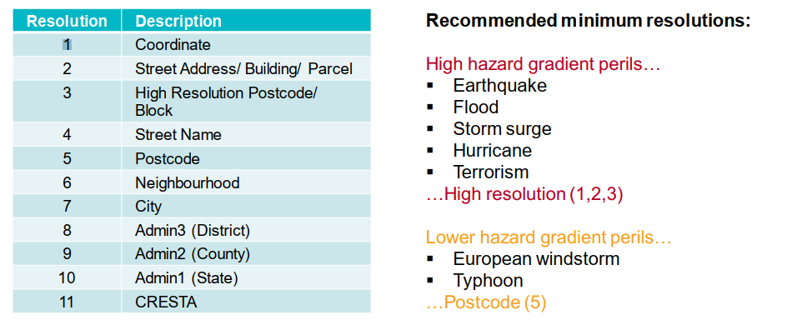

**HAZARD MODULE**:

**Local Hazard Identification**: Local site conditions play a crucial role in determining how likely an area is to damage from various hazards

**Location Event Modelling:** Key hazard parameters for each stochastic event at each location are returned

Both of these processes can inform the model of the key hazard parameter

**WINDSTORM: process for single event**

* Take an idealized wind field at each point along a storm track

Surface Roughness: 10 roughness categories and Impacts peak wind speed

Site-level hazard: Conversion of wind speed to peak gust and Peak gust stored at VRG level

**VULNERABILITY MODULE**:

A vulnerability is used to relate the physical aspects of an event, such as its intensity or magnitude, to the level of damage it causes.

Represented by the mean damage ratio (MDR)

we know a location’s replacement value and event hazard, we can determine MDR and, therefore, loss

Vulnerability functions are uniquely defined by the four primary building characteristics

* Construction Class
* Occupancy Class
* Number of Stories
* Year Built
* Floor Area

If any of the four primary characteristics are not known: the Building Inventory is invoked

Uses valid address information to estimate likely building characteristics based on regional building characteristic statistics

Secondary modifiers are not applied

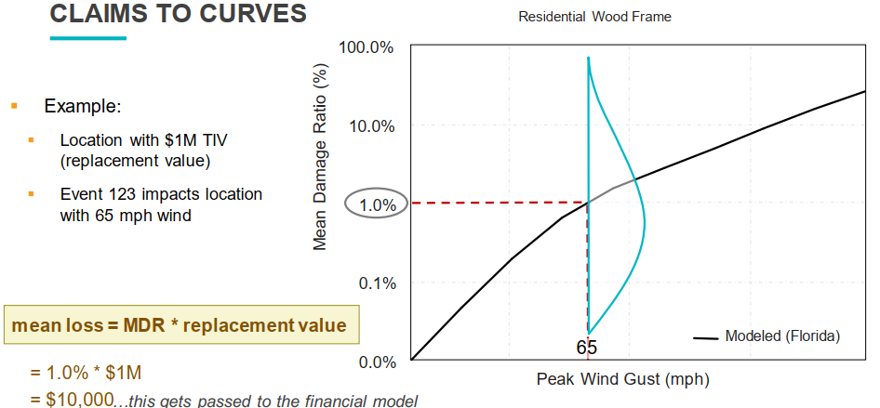

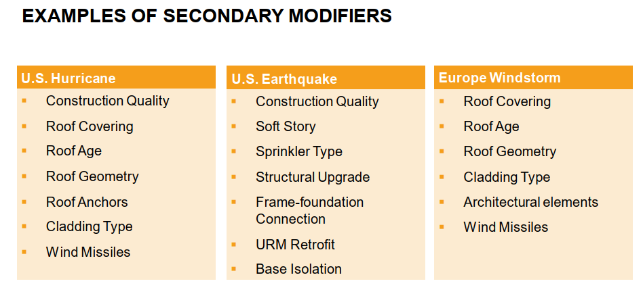

**Economic Demand Surge**

Component of post event loss amplification that quantifies the increase in the costs of building materials and labor costs as demand exceeds supply. Has the biggest overall impact on loss amplification.

**MODEL OPERATIONS**

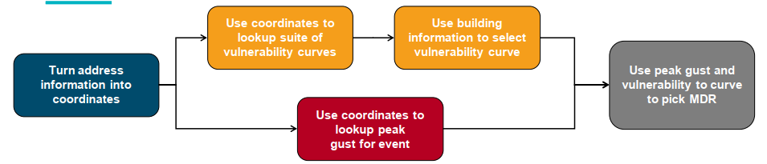

**Demand Surge:** Demand surge is the increase in prices for labor and materials following a catastrophe, as construction material and contractors' costs increase along with the increased demand for repairs and replacement construction.

**Disaggregation:** Disaggregation is the process by which Touchstone distributes aggregate exposure data from a coarse resolution (such as CRESTA) to a finer resolution more suitable for detailed catastrophe modeling. At a high level, the steps to disaggregate the aggregate exposure data